CITY UNIVERSITY MALAYSIA

CMS

USER MANUAL

FOR

**DATIN’S PROPERTY MODULE**

**WARNING!  
ONLY FOR DATIN’S PROPERTY**

CMS User Manual is dedicated to the CMS user. This User Manual will provide a guideline to the user on how to use the system.

Table of Contents

HOW TO ADD A NEW ITEM 3

HOW TO UPDATE AN ITEM 5

HOW TO ADD A NEW TYPE/CATEGORY 8

HOW TO UPDATE A TYPE/CATEGORY 11

# HOW TO ADD A NEW ITEM

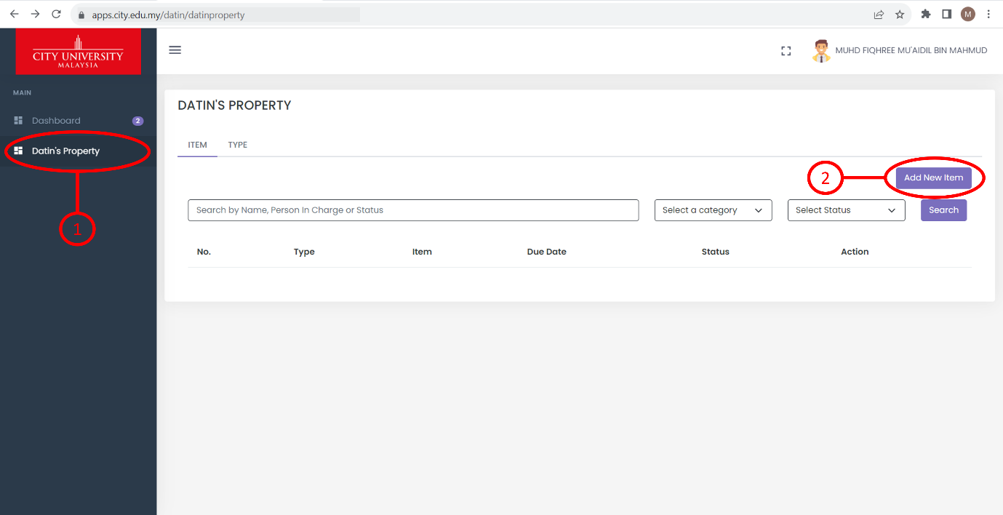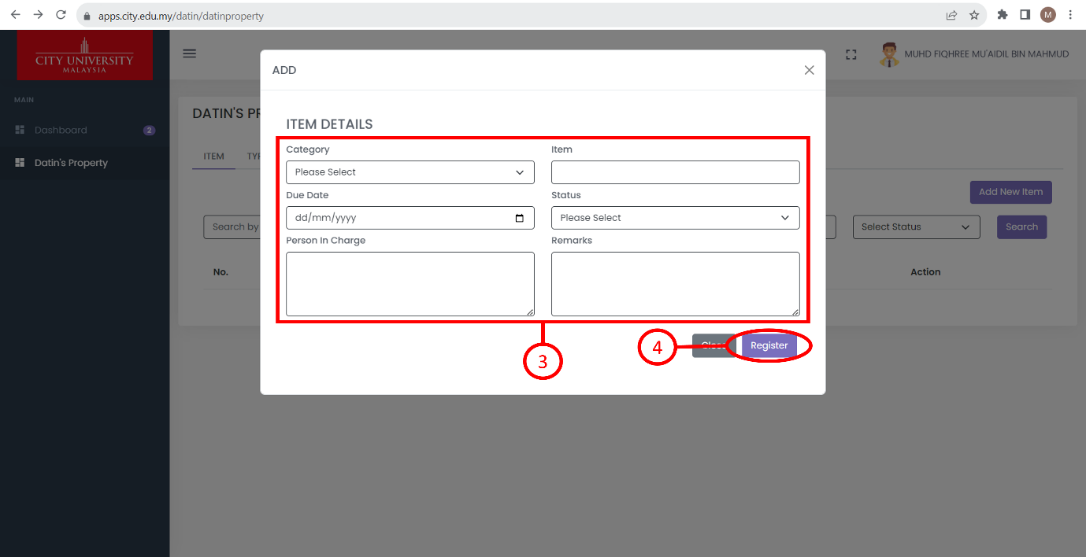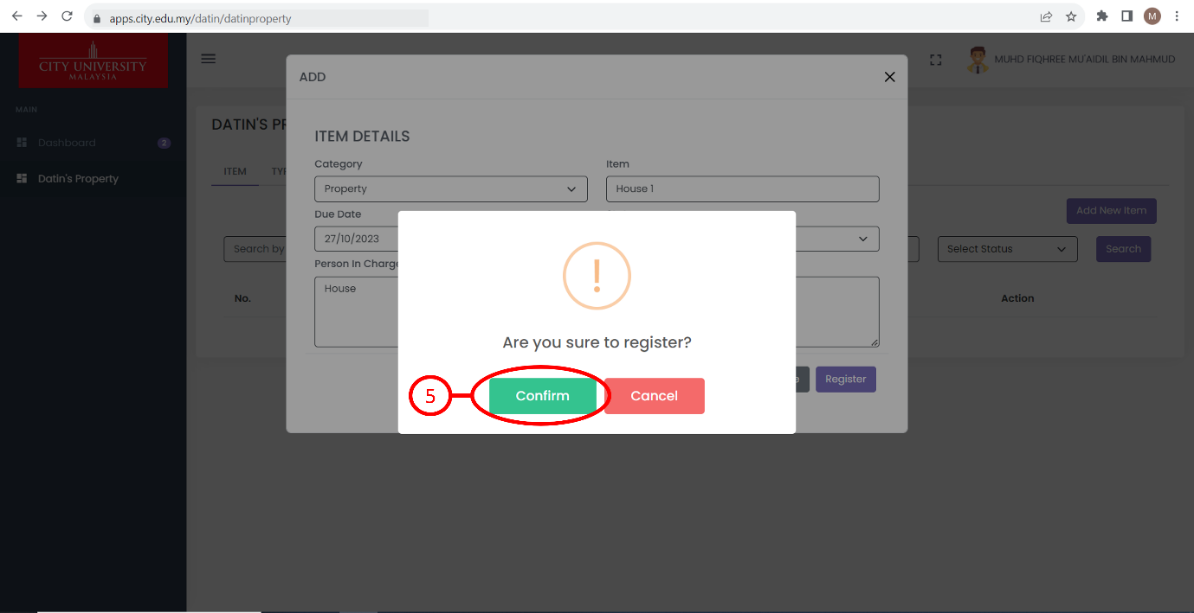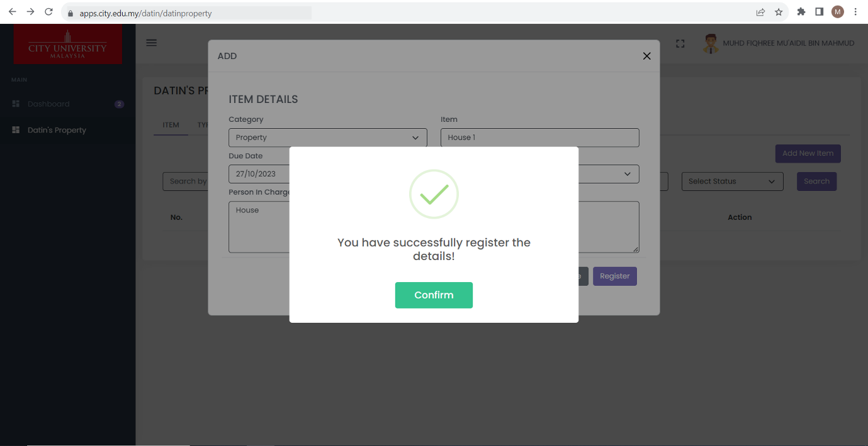

Steps

1. Click “Datin’s Property” on the navigation menu.
2. Click the “Add New Item” button and a page will appear.
3. Fill in the necessary blanks and dropdowns. Remarks are optional.
4. Click the “Register” button. A pop-up will appear.
5. Click the “Confirm” button. A pop-up will appear to confirm that the item has been successfully added.

# HOW TO UPDATE AN ITEM

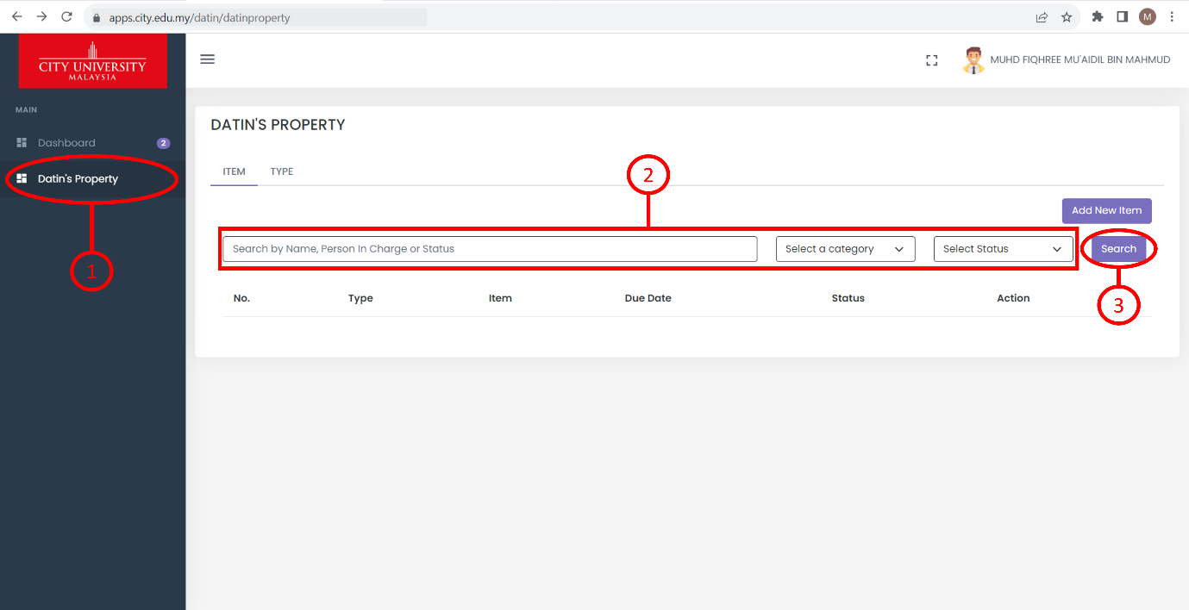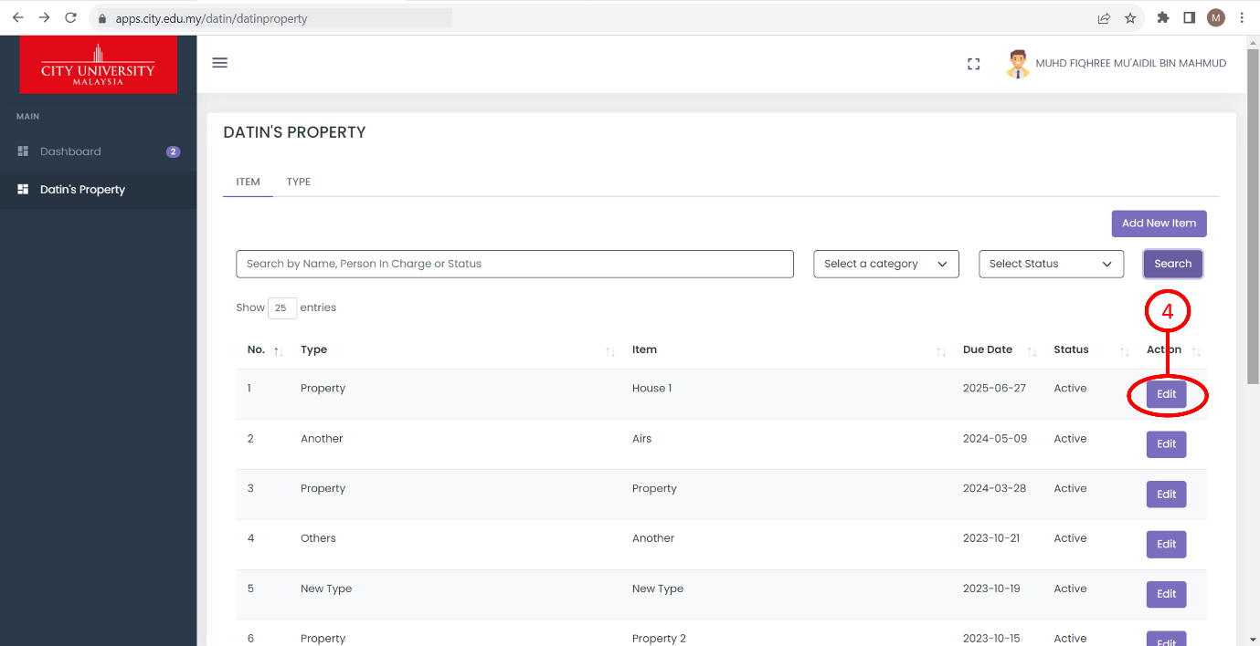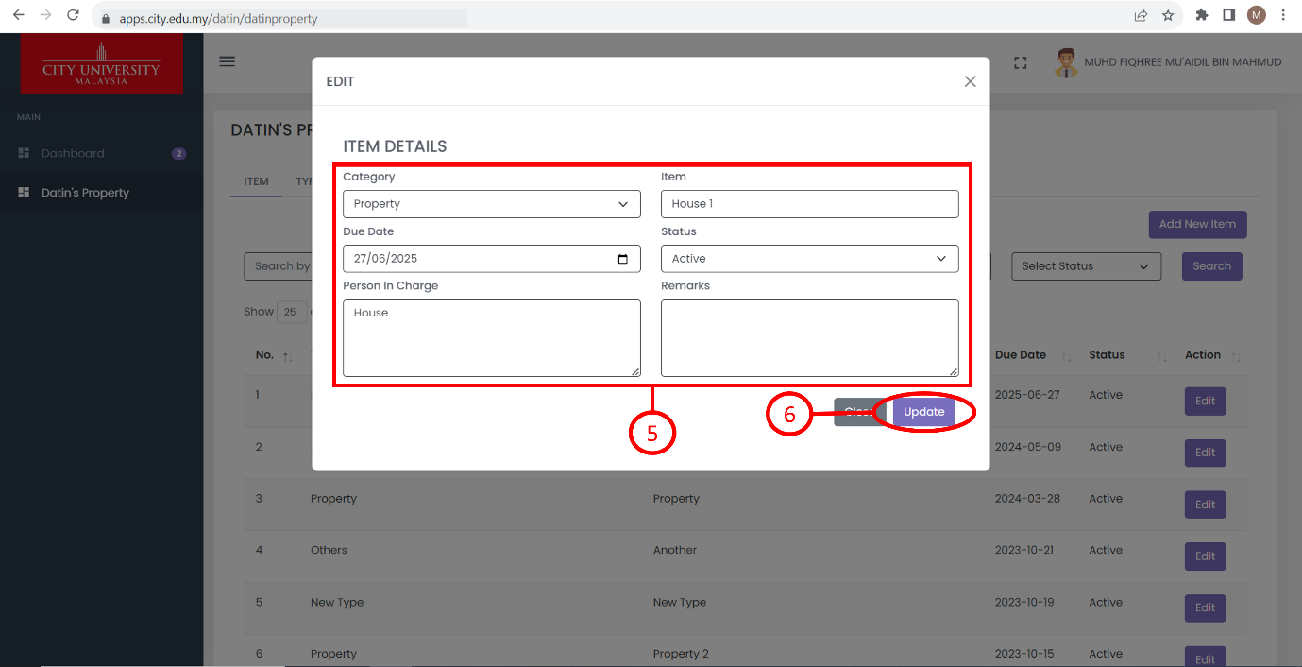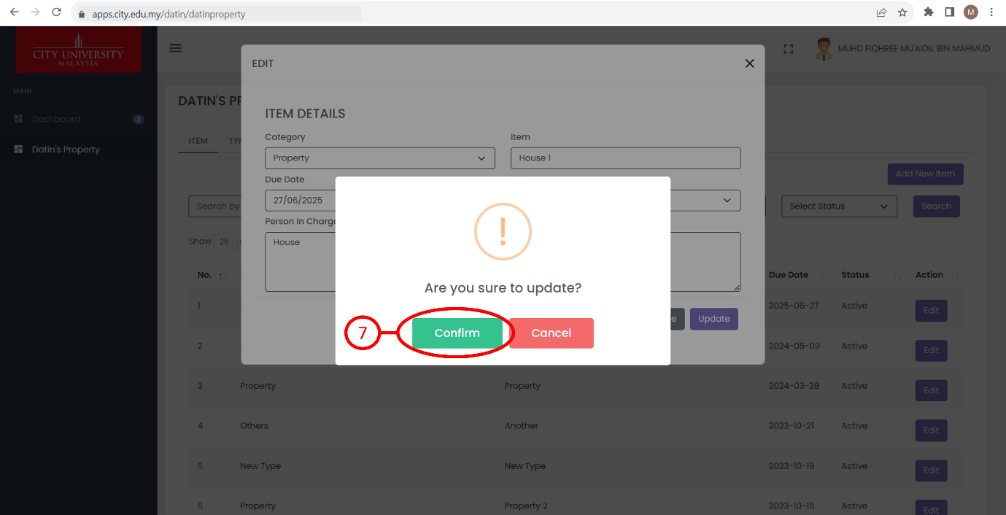

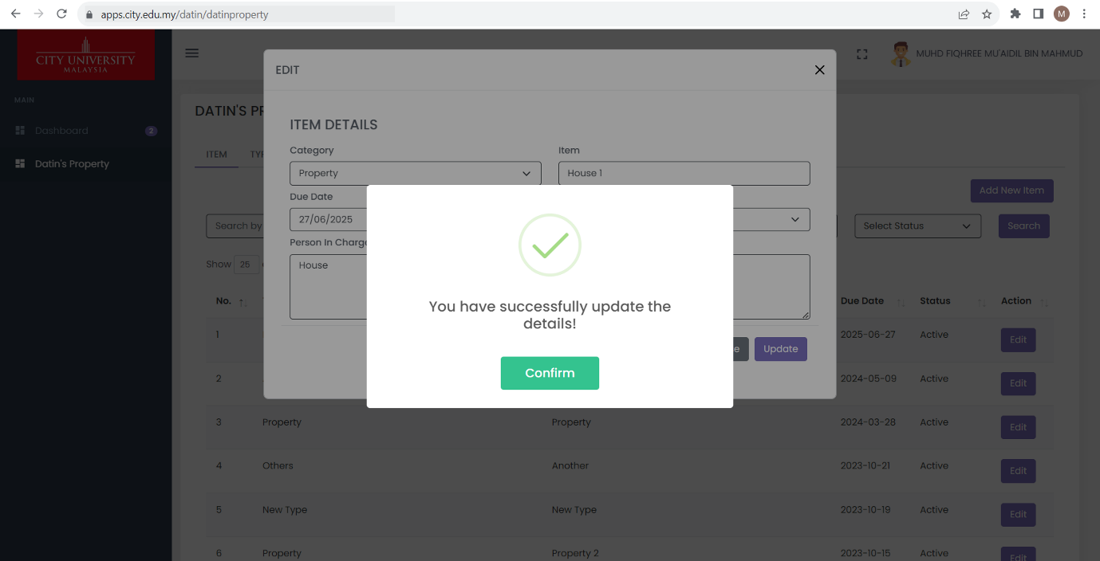

Steps

1. Click “Datin’s Property” on the navigation menu.
2. Fill in the search bar or select the dropdown to filter the search function.
3. Click the “Search” button. Based on the previous step, if there’s no input given, the search function will display all items.
4. Choose an item and click the “Edit” button. A page will appear.
5. Update the details.
6. Click the “Update” button. A pop-up will appear.
7. Click the “Confirm” button. A pop-up will appear to confirm that the item has been successfully updated.

# HOW TO ADD A NEW TYPE/CATEGORY

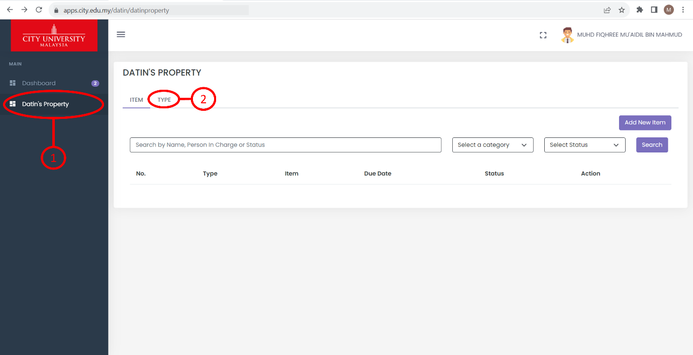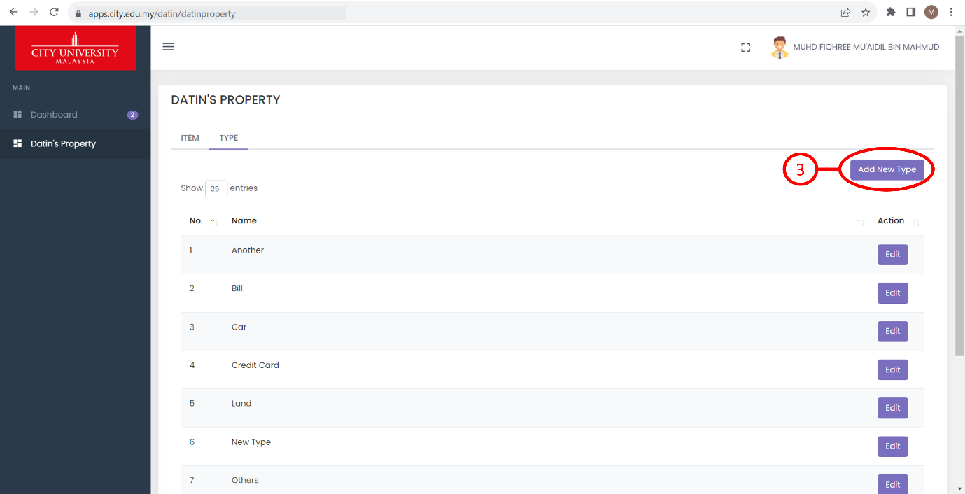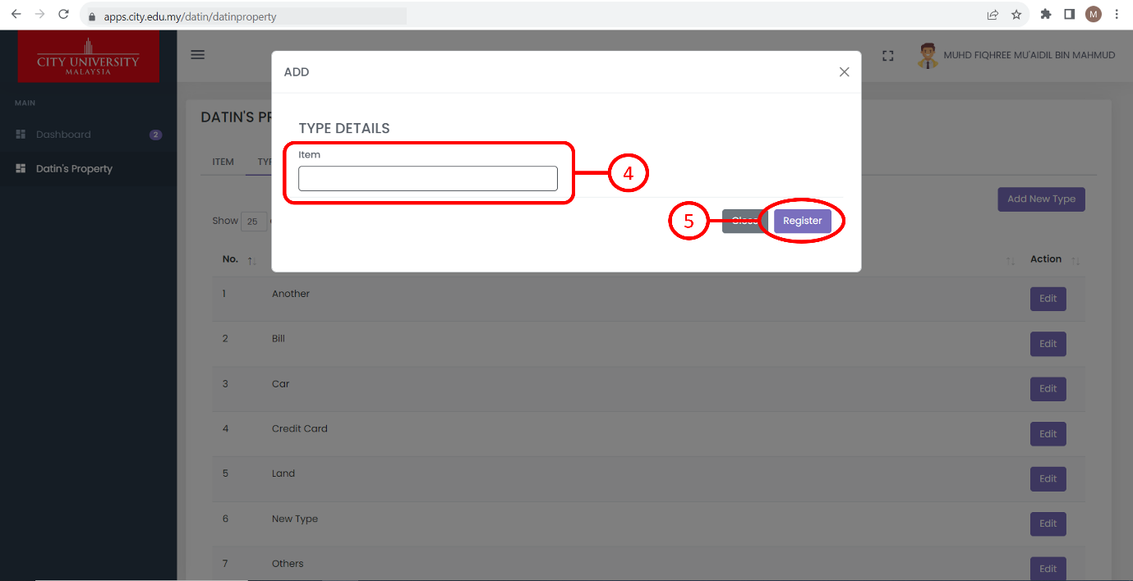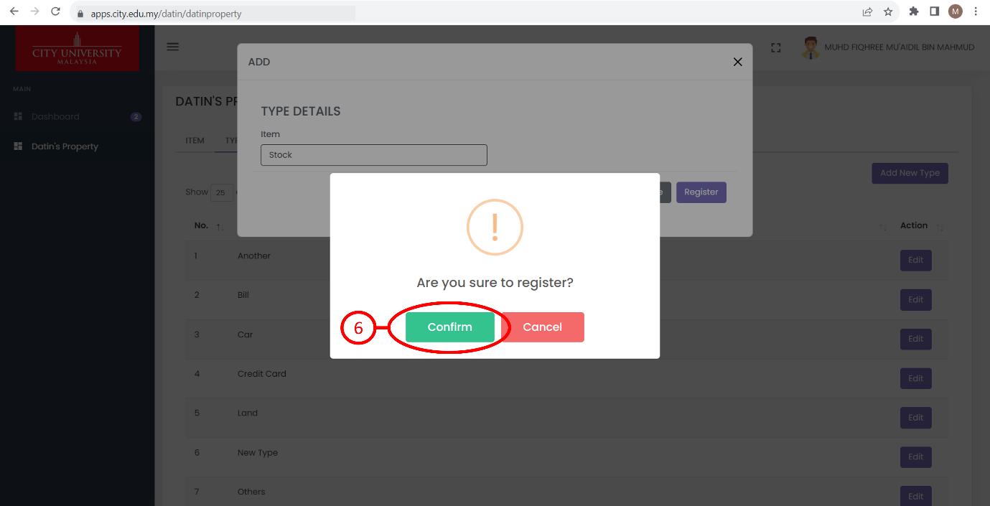

Steps

1. Click “Datin’s Property” on the navigation menu.
2. Click the “TYPE” on the navigation bar.
3. Click the “Add New Type” button and a page will appear.
4. Fill in the textbox.
5. Click the “Register” button. A pop-up will appear.
6. Click the “Confirm” button. A pop-up will appear to confirm that the type/category has been successfully added.

# HOW TO UPDATE A TYPE/CATEGORY

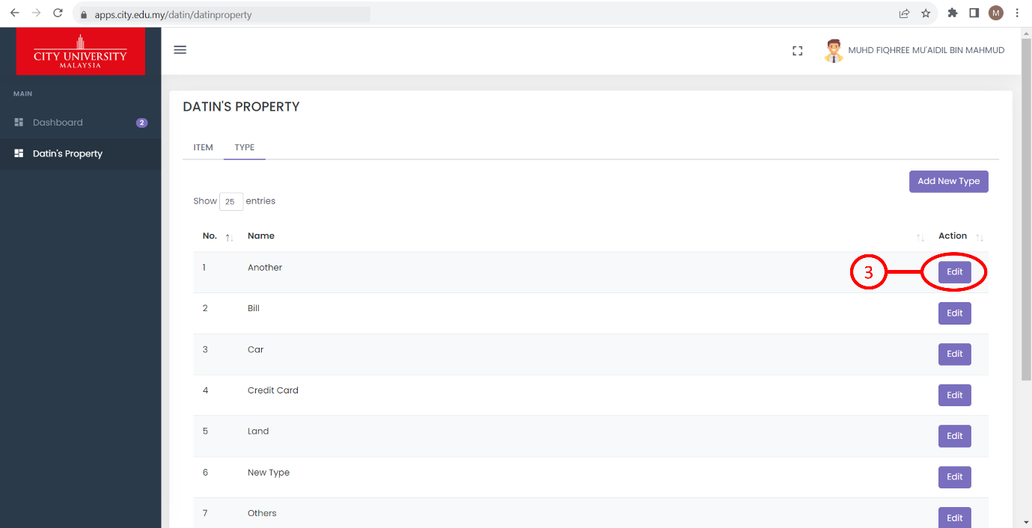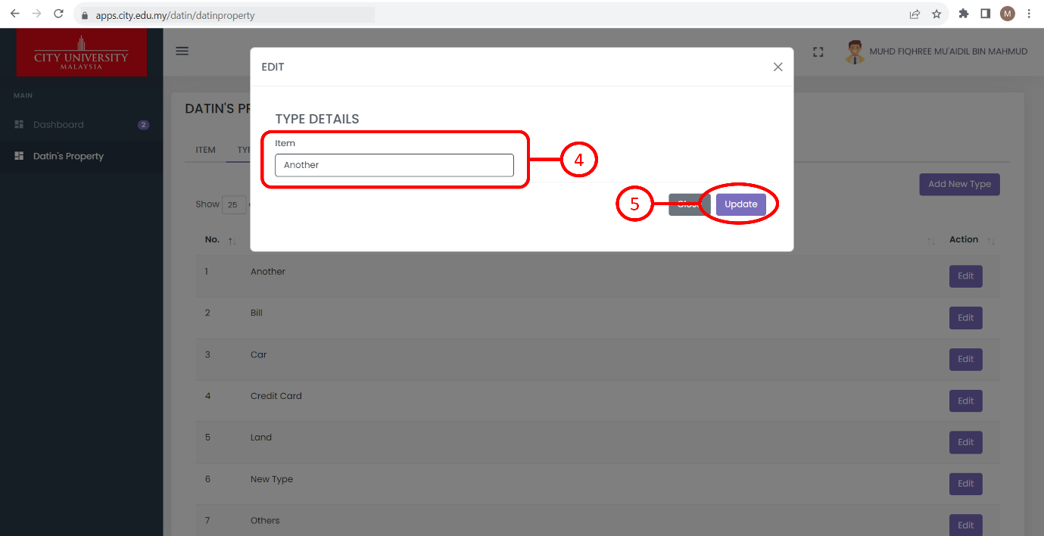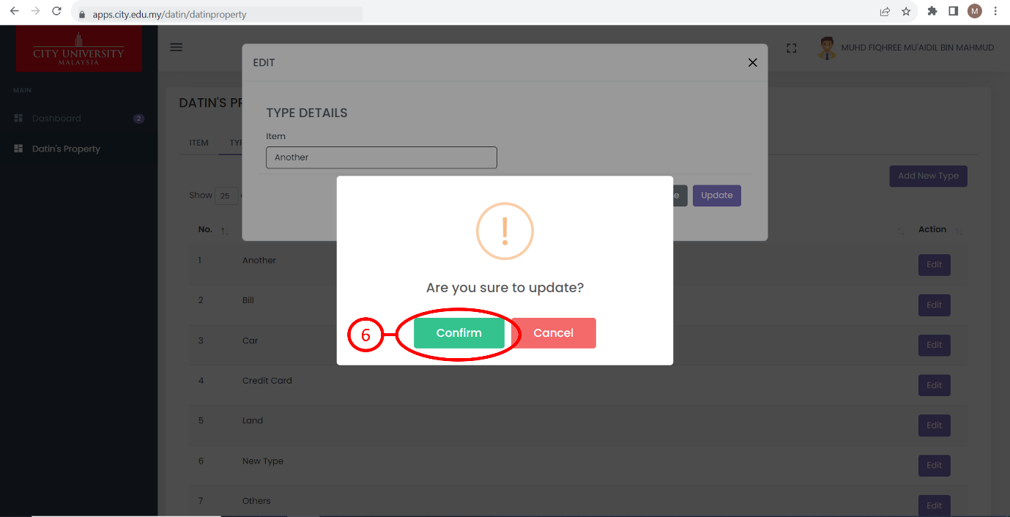

Steps

1. Click “Datin’s Property” on the navigation menu.
2. Click the “TYPE” on the navigation bar.
3. Choose a type/category and click the “Edit” button. A page will appear.
4. Update the details.
5. Click the “Update” button. A pop-up will appear.
6. Click the “Confirm” button. A pop-up will appear to confirm that the type/category has been successfully updated.